**Write a Simulink code for speech encoding**

**Simulation flowchart:**

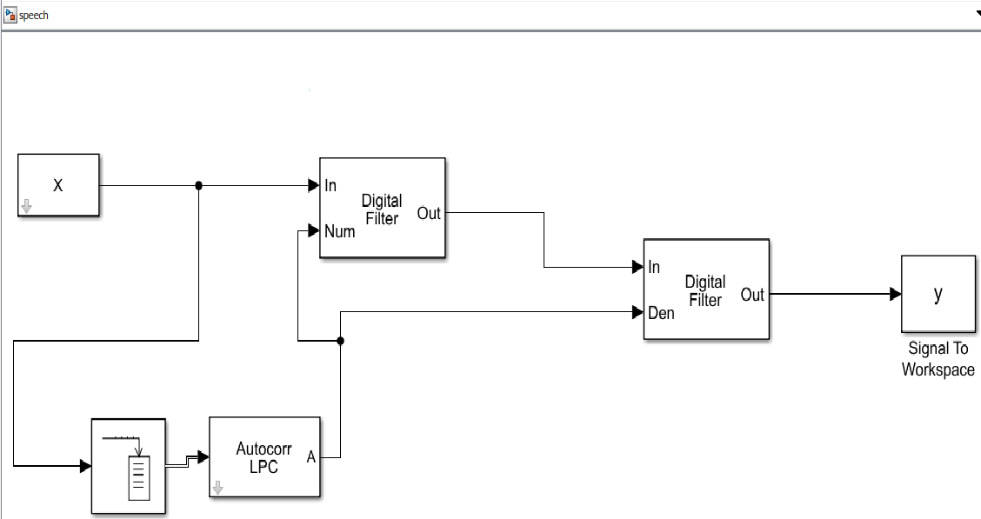

**Input:**

X=audioread('bjp.wav');%converting the input signal into samples

X=X';%converting column matrix into row matrix

y=y';%converting column matrix into row matrix

sound(y);%sound test output

sound(X);%sound test intput

plot(X);

figure ; plot(y);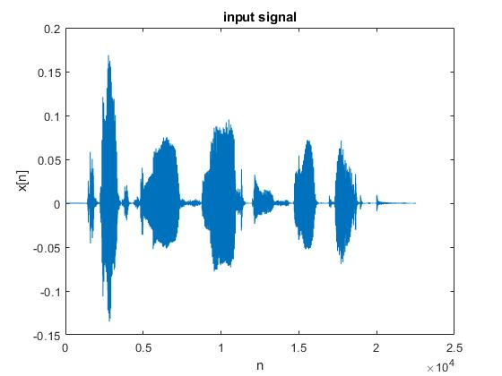

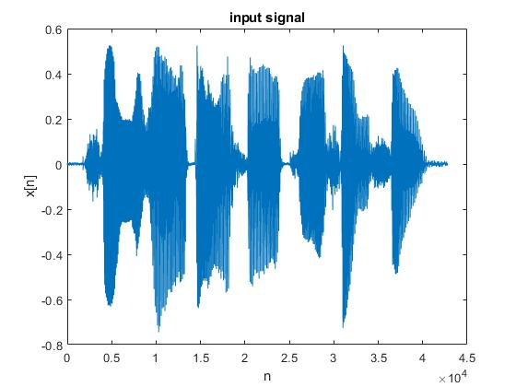

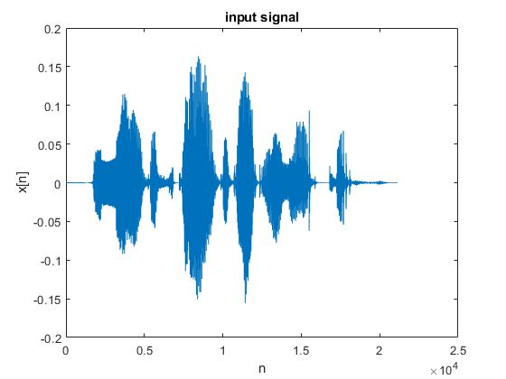

**Respective Output :**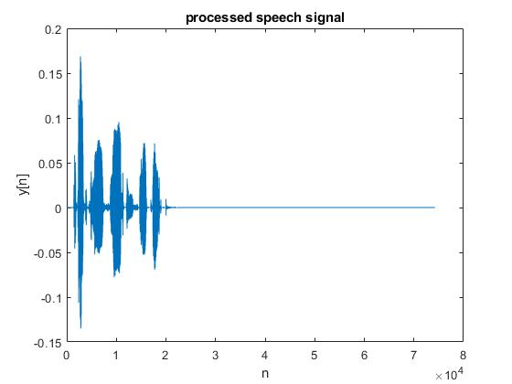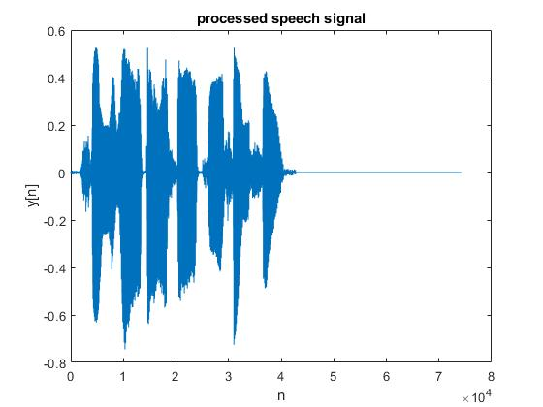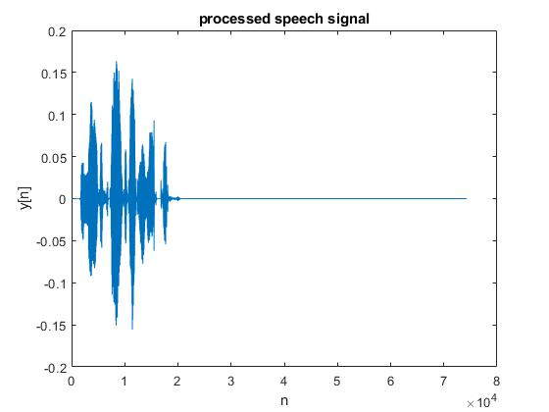

**Write a matlab simulation for cepstrum analysis of a signal**

**Simulation flowchart:**

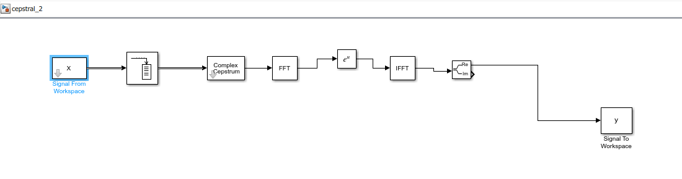

**input:**

X=audioread('bjp.wav');%converting the input signal into samples

X=X';%converting column matrix into row matrix

y=y';%converting column matrix into row matrix

sound(y);%sound test output

sound(X);%sound test intput

plot(X);

figure ; plot(y);



**Respective output:**